**PHỤ LỤC**

**A. Các sơ đồ tuần tự tương đương:**

# ThemNhaCungCap_NormalFlow

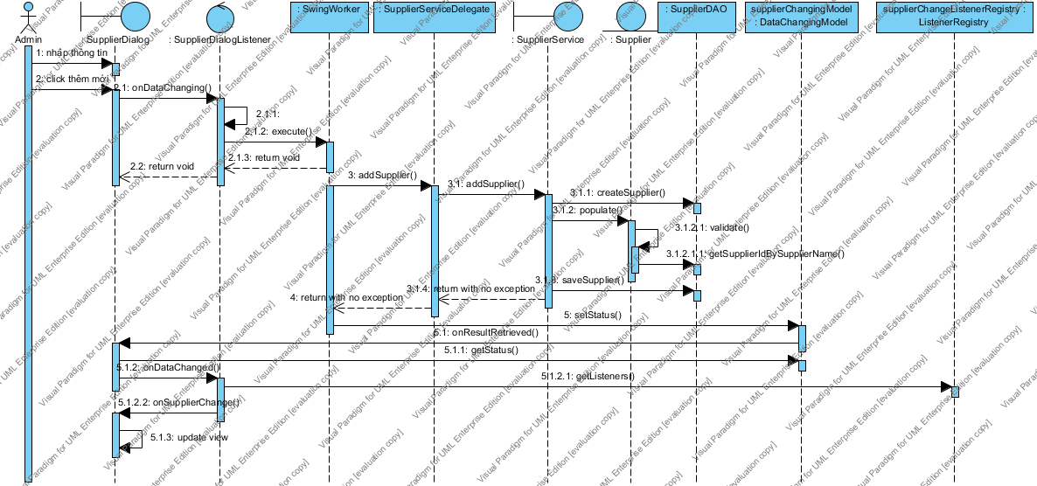

# ThemNhaCungCap_ValidateFail

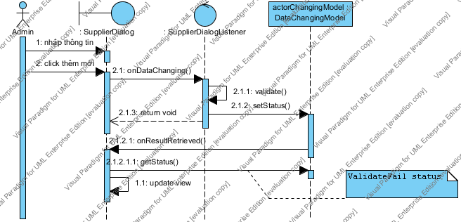

# ThemDaoDien_NormalFlowImage14.png

# ThemDaoDien_DuplicateImage15.png

# ThemNickChat_NormalFlowImage16.png

# ThemNickChat_ValidateFail

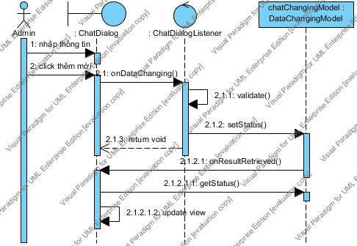

# ThemLoaiPhim_NormalFlow

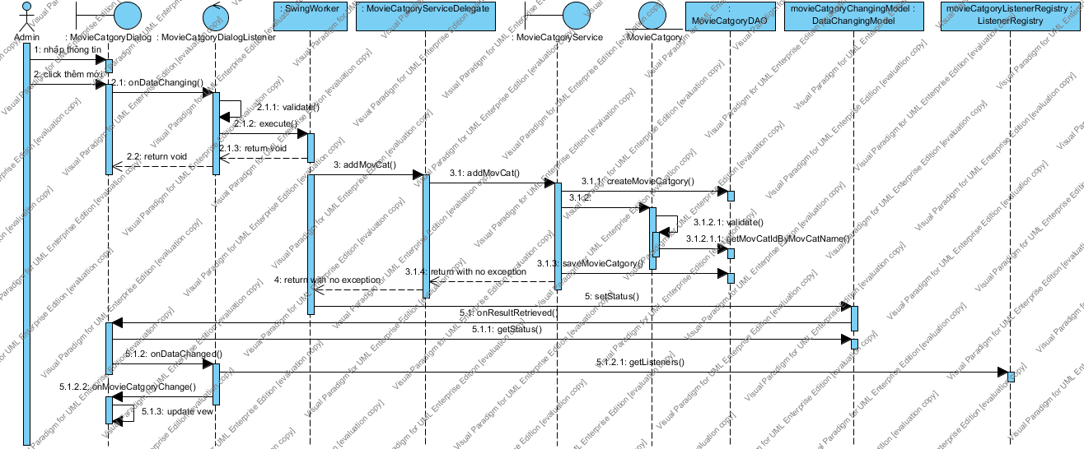

# ThemLoaiPhim_ValidateFail

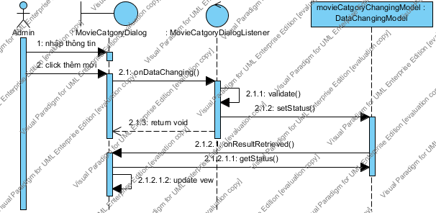

SuaDaoDien_NormalFlow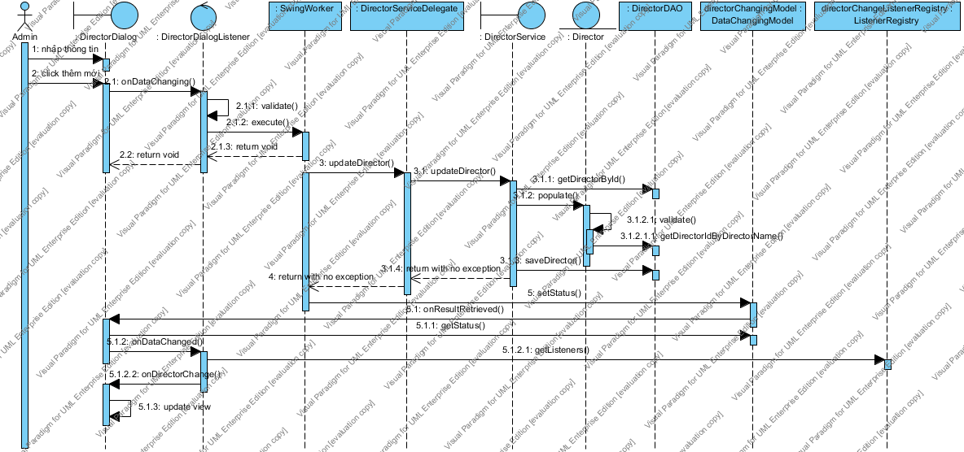

# SuaDaoDien_FailImage23.png

# SuaDienVien_NormalFlow

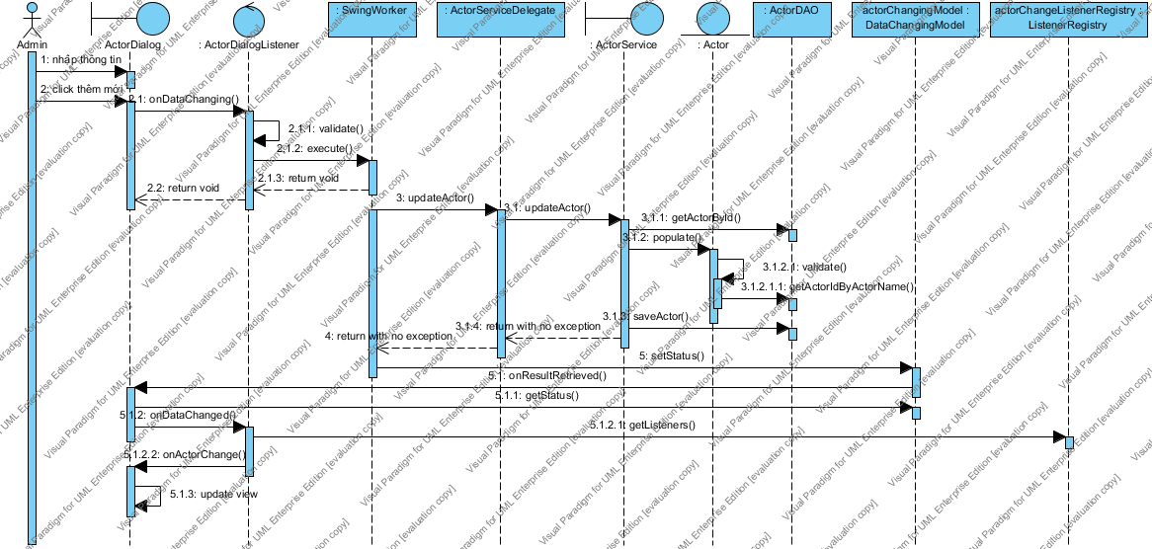

# SuaDienVien_Fail

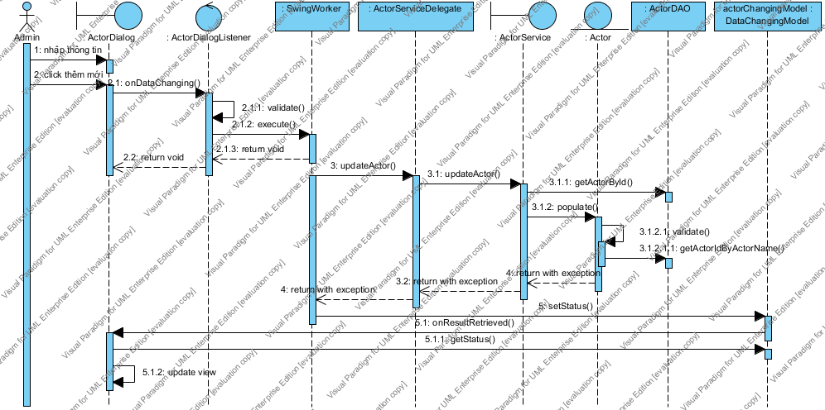

# SuaLoaiPhim_NormalFlowImage26.png

# SuaLoaiPhim_Fail

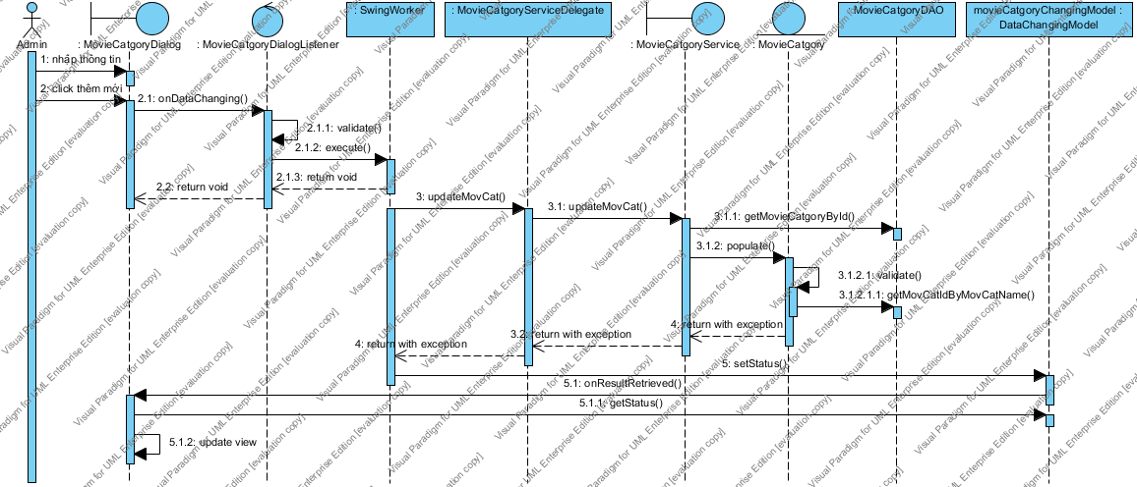

SuaNickChat_NormalFlow

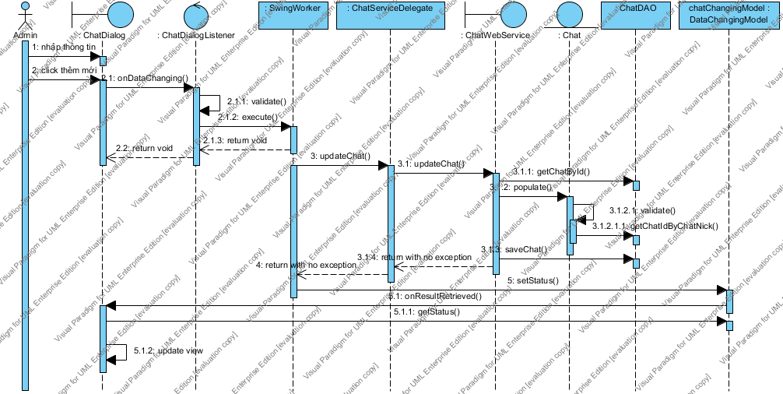

# SuaNickChat_Fail

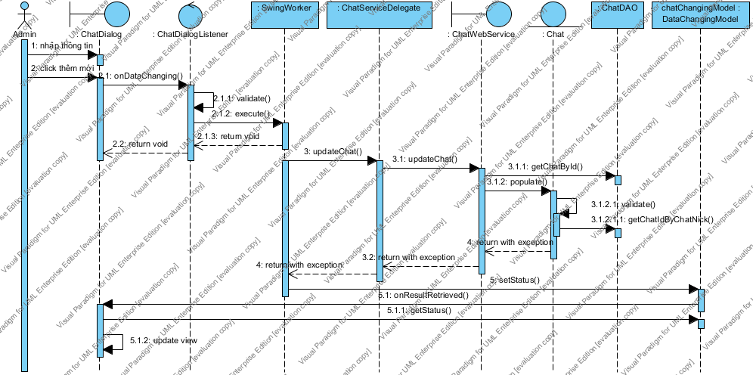

XoaDaoDien

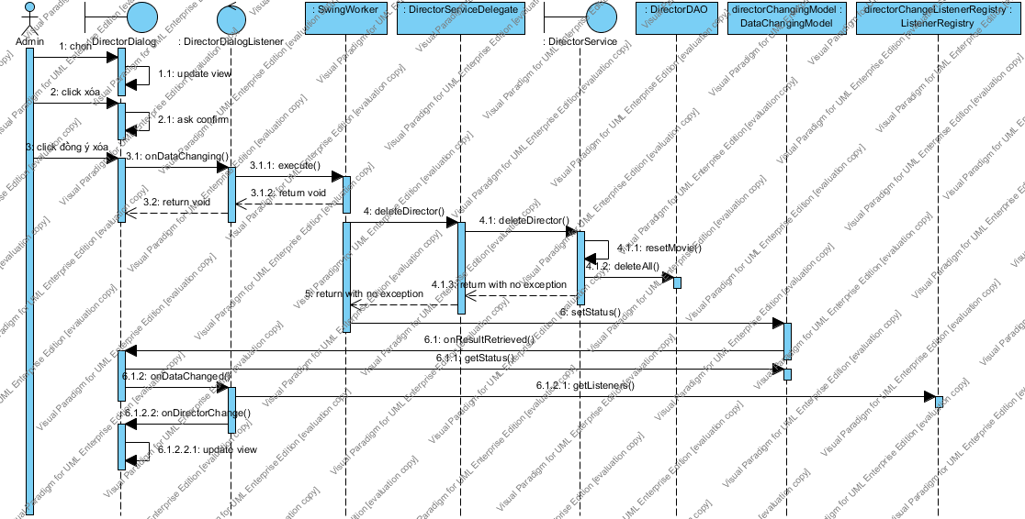

# XoaDienVien

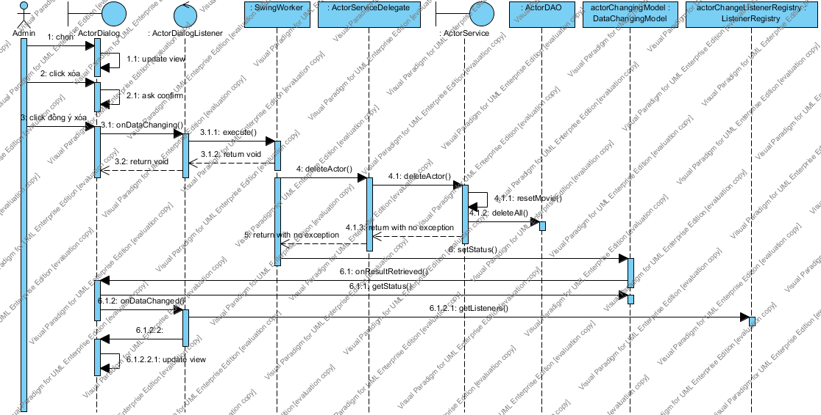

XoaLoaiPhim_NormalFlow

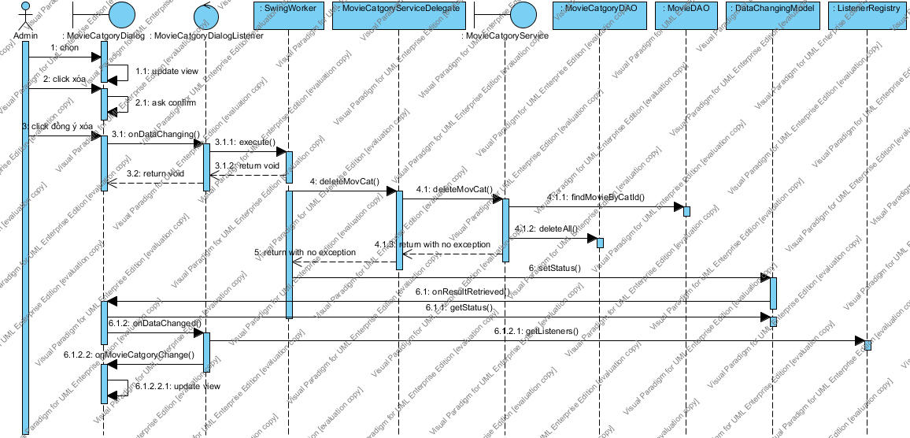

# XoaLoaiPhim_Fail

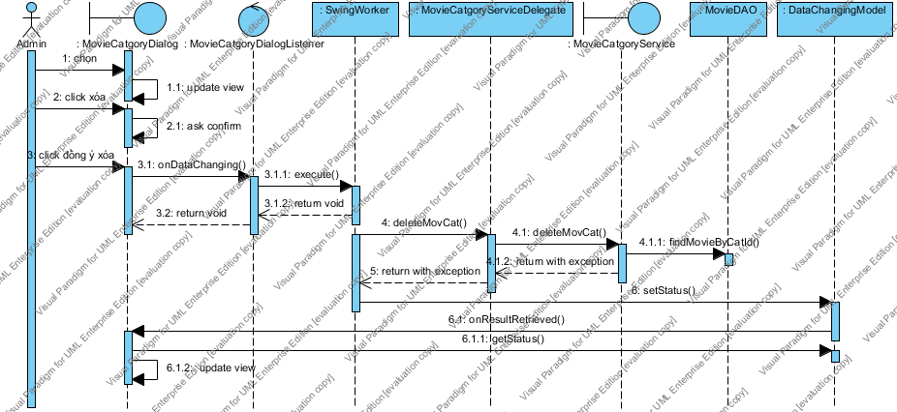

# XoaNickChat

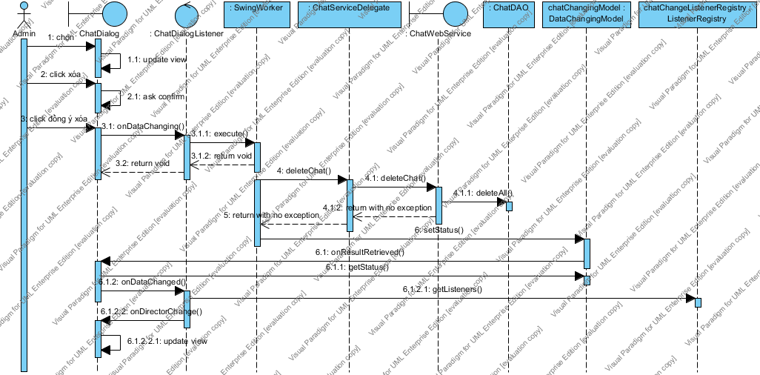

# SuaPhim_NormalFlow

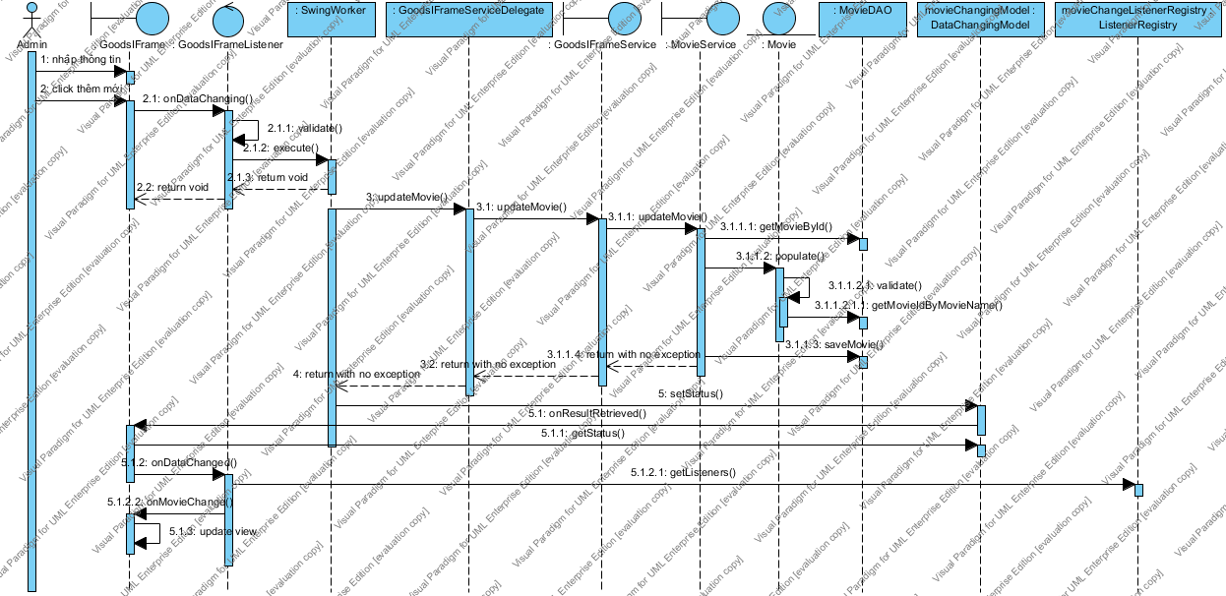

# SuaPhim_Fail

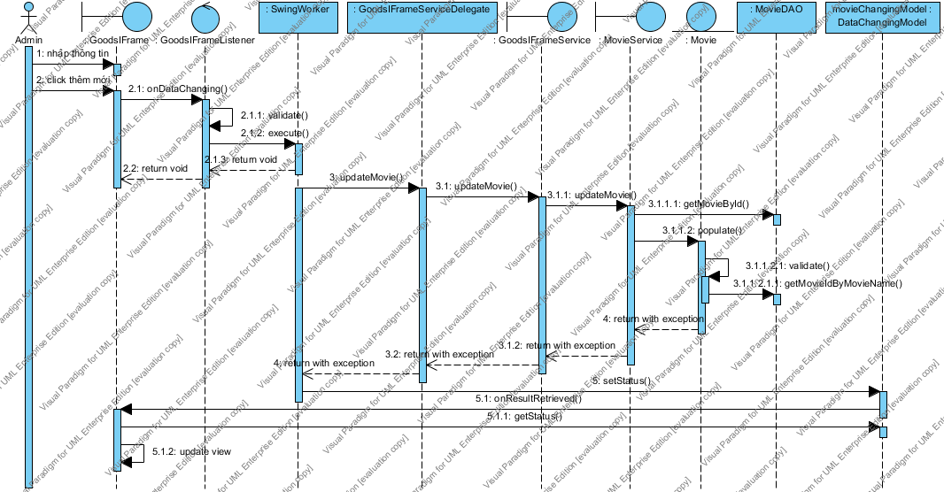

# XoaPhim

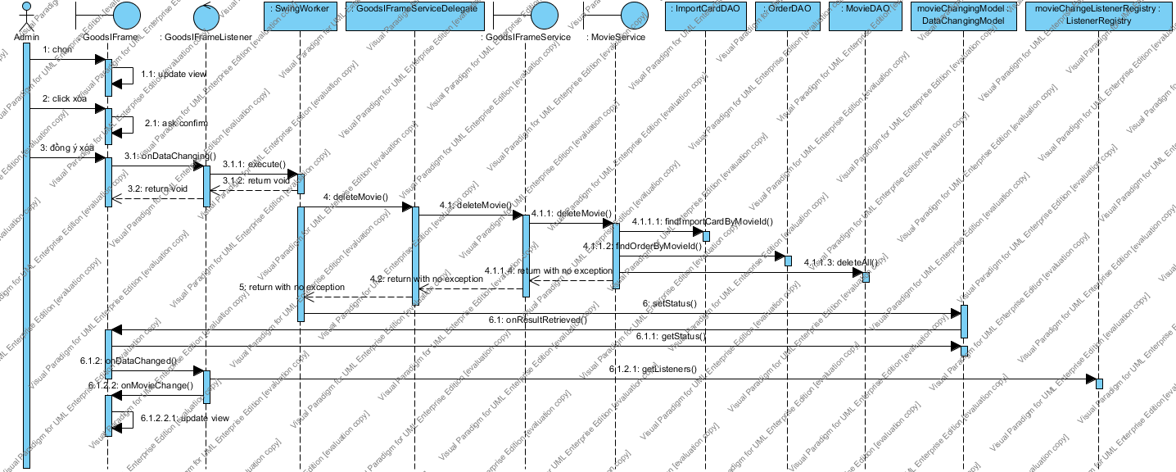

# XoaPhim_Fail

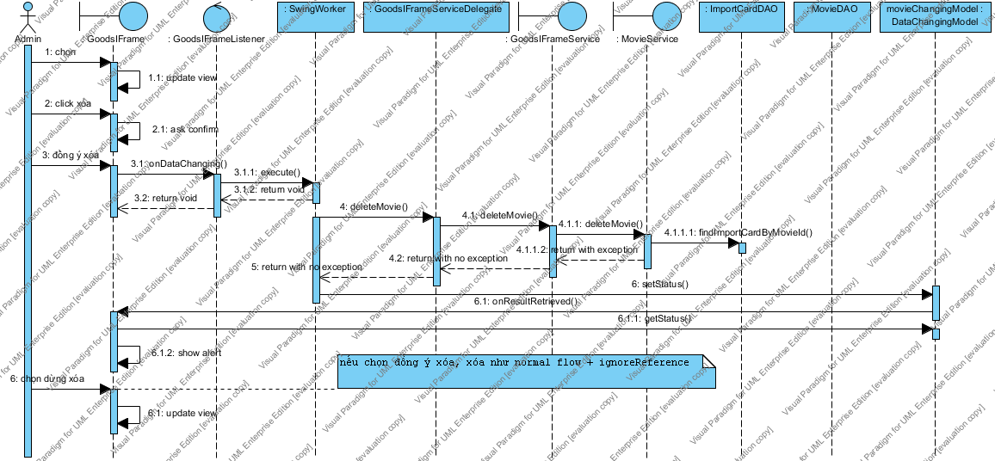

**B. Một số tài liệu tham khảo:**

- Core Java Fundamental I, II

- Professional Java JDK 6 Edition - Wrox

- SCWCD –Manning

- Struts 2 in Action – Manning

- Hibernate in Action – Manning

- POJO in Action – Manning

- Spring in Action – Manning

- Active MQ in Action – Manning

- Enterprise Java with UML – Wiley

- Jasper Report Ultimate Guide